**Element Quiz Documentation**

**Section 1.1 Generating Report Overview**

The report generating feature is used to save a PDF version of the portfolio report to user’s computer.

The report generating feature is divided into four sections: user input, information transfer between two sites, pie chart and table generation, and “print” (save as PDF). Detailed explanations can be viewed in the corresponding sections.

In this report, there are several sections requiring users to fill in when they finish their Element Quiz: client name, client address 1, client address 2, client address 3, advisor name, firm name, advisor phone number, date and class type.

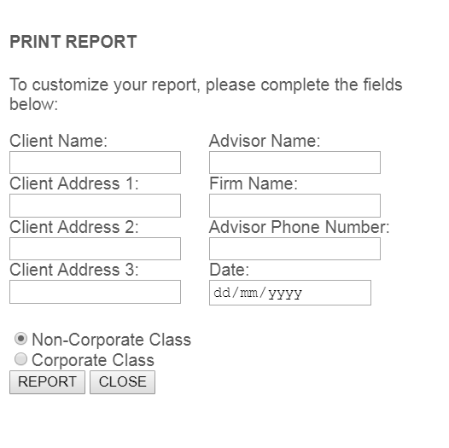

When user clicks on the “REPORT” button, a new webpage will open, and display the report:

 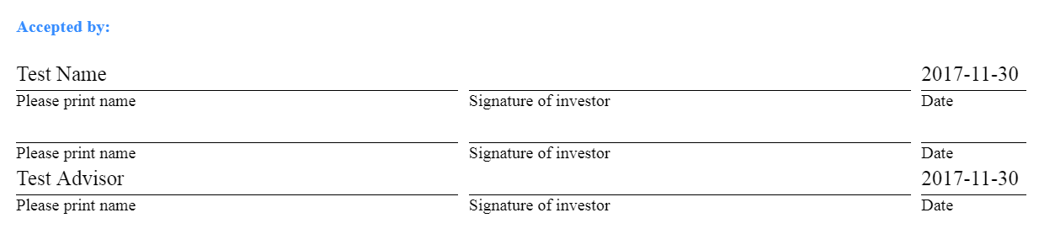

The element quiz page and report page are two seperated web pages. In order to pass information from one site to another, query string is used. Example:

*“report-conservative.html?form/client-name=Test%20Name&form/address1=100%20King%20St&form/address2=&form/address3=&form/advisor-name=Test%20Advisor&form/firm-name=Test%20Corp&form/phone=647-100-1000&form/date=2017-11-30&form/class-name=Non-Corporate”*

Notice that there are one pie chart and three tables in a single report, for example:

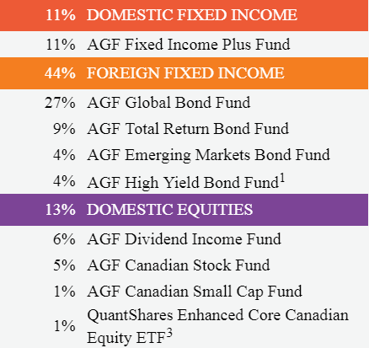 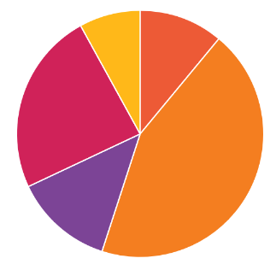

All the data in the table and pie chart is dynamic, which means the data is not directly wirtten in the HTML. There is a JSON file (data definition) used to store all the necessary data. Functions are implemented in order to populate data into correct position.

On the top left of the report, there is a “Print” button:



This print is based on browser’s print functionality. When user click on this, a pop-up will show to let user select the print location( printer’s name or save as PDF). The print version has slightly different format with screen (web site) version. Two CSS stylesheets are liniked to the HTML homepage (the report page).